PalestineRemembered.com

* The Longest Dispossessed Refugees Of The 20th century
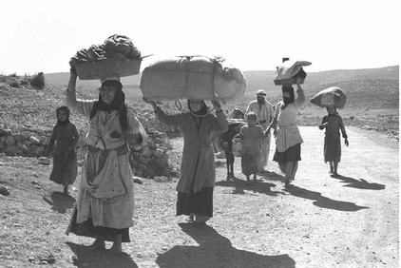
Ethnically cleansed Palestinians fleeing their homes to Lebanon, Oct. 1948

Palestine Remembered contains the most comprehensive online database about the 450 ethnically cleansed and destroyed Palestinian towns and villages. At the website, you will find:

- Rare photos and eyewitness accounts depicting the destruction and ethnic cleansing of the Palestinian villages.
- Detailed maps of Palestine prior to the 1948 war.
- Vital British Mandate statistics about Palestine and its people prior to the 1948 war.
- Detailed history about the evolution and core issues of the Palestinian-Israeli conflict.

Sadly, the collective dispossession and ethnic cleansing of the Palestinian people for the past 55 years has been purposely under represented in the Western media. We hope your future visits to the website would expose you to the Palestinian prospective of the conflict.

* PalestineRemembered.com is a non-profit organization dedicated to preserving the collective experiences of the 5.9 million dispossessed Palestinian refugees.

